Research Question

Can we create an easy to use housekeeping reporting application which will assist small to medium size accommodation suppliers to reduce waste of time and hence reducing the cost?

Literature Review

1. **Introduction:**

(Ivanović, 2008). In most accommodation industry the most significant cost of running an accommodation tends to be associated with human resources. In most hotels and motels the payroll is the single biggest cost, Where as the in a restaurant and or a bars it tends to be second, to cost of materials, such as food and beverages. In small accommodation suppliers line manager tends to be the owner that manages the staff whereas in larger industry the line manager will be assisted by the staff management issued by human resource and or personnel managers.

As the accommodation industries worldwide are a very large industry therefore it is fair to ensure that a literature review is conducted. This Literature review will revolves around the accommodation industries processes in housekeeping and their PMS (Property Management System). We will be comparing other systems which are available in the market which utilize either android based application and or application which has the features to assists the accommodation supplier with housekeeping reporting to the front desk and looking at features on the bigger platform to try and utilize them in more user friendly manner.

* 1. **HI Box**

(HIBOX, 2019). HiBox is a multi platform application thus provides advanced interactive information and entertainment solutions for customer and commercial application. One of which is the Hibox hospitality which provides the customers with user interface to better manage the housekeepers and is integrated to PMS (Property Management System) which has been created by

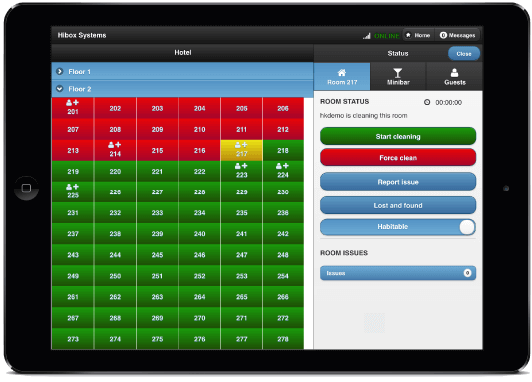

Fig1: HIBOX website

Staffan Granholm CEO and the team of the company. This application is subscription based, this allows small companies to afford it and to use it and to see how or if it benefits the company. Application features consists of allowing housekeeping staff to report the usage of mini bar within the units and that information automatically registers it to the PMS therefore allows the front desk to view it. The application also allows housekeepers to take photos and report any broken or lost and found items within that room so the front desk is aware of items lost or damages done by the guest so the front desk can chase them up regarding lost items or charge them for damages to the property. There system operates on the browser therefore you just need a provided URL and login with your credentials and your basically ready to use the program.

* 1. **Know cross**

(Knowcross, 2019) Knowcross was founded in the year 2002 which prides its self to be quote “Help improve guest service and enhance staff productivity and increase guest loyalty” which this company stands by. This company spans to more than 40 countries and provides 24/7 support. The company offers Saas (Software as a service) therefore it mean that the companies services are cloud based and that it’s a subscription based software and can be accessed online

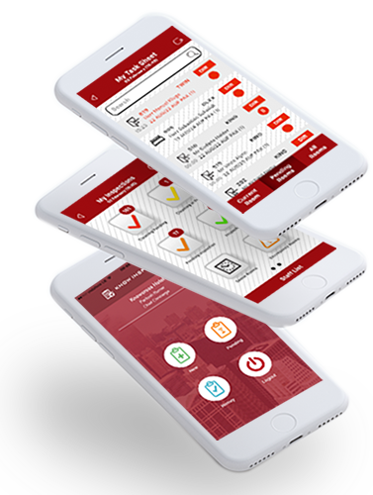

Via browser, which mean that the software doesn’t have to be installed on any computer and therefore doesn’t require any extra hardware requirements to run this application however they do provide an option to clients to have a hard copy of the software if the customer requires it. Know housekeeping does also provide easy to use application on android and IOS devices hence making it much easier to the user built into the application has options to select Multilanguage interface to reduce language barrier. This application also can contacts to your PMS therefore the front desk will be aware of rooms which are dirty, clean, inspected. Know Housekeeping applications automatically allocated rooms and will prioritization rooms depending on guest requests of early check-in. Know Housekeeping will also look at your linen count and will report to front desk to order more linen and will calculate depending on how many check out of how much linen is required.